The 7-6-7 Challenge
Get 7 Invites each day for 7 day to watch a 6-Figure annual income earner explain why the Ambit Energy opportunity is for you. Each day at 12:00 Central and 7:00 PM Central (Jan 22nd – Jan 29th) we will be doing a live Zoom call on the Ambit A-Team’s facebook’s page: https://www.facebook.com/AmbitATeam. To maximize the exposure, we will be asking each team member to promote one hour before and do a Facebook Watch Party of this live broadcast.

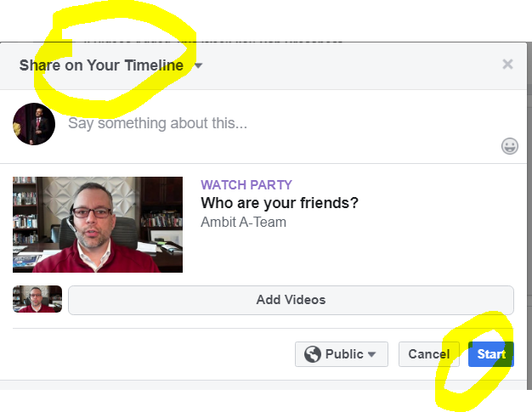
Inviting seven people each day to the Facebook Live Presentation is a snap because we are providing you with the exact scripts! Let’s all really do this together and create a serious buzz!!!
Choose from these scripts and call/text/message away!
Option A: Hey FIRST NAME, as you might know I’m always looking to elevate my game in the entrepreneurial world. Well I’ve just added an additional project to my portfolio that’s very exciting! If I sent you an invitation to a special webinar overview of this business, would you listen in? I really want you to see this 10 – 15 minute overview!

Option B: Hey FIRST NAME, I’ve got just a minute – I’m involved in an exciting project and we are doing some beta testing with presenting it through social media and I want you to hear about it. If I sent you an invitation to a special webinar overview of this business, would you listen in? I really want you to see this 10 – 15 minute overview!

Option C: Hey FIRST NAME, what’s going on? A few of my business partners who have earned in excess of six figures per year with it are developing a new project that is a very exciting way to present the opportunity through social media! We are inviting part-time partners for the expansion of this and I’ve been invited to join in. WE are assembling a larger team and I want you involved. If I get you a spot in the group, would you jump on the call?

After they say yes, Okay sounds good. I will send you a text about 10 minutes before with a link so that you can get logged in

10 Minutes before: Hi FIRST NAME, here’s the link to jump on the business overview call:
I’m logging in right now too. The person speaking is very well respected and we’re fortunate to have them available! Be ready to take notes; see you there!

